

**DEPARTMENT OF COMPUTER SCIENCE**

**FACULTY OF COMPUTING & ARTIFICIAL INTELLIGENCE**

LAB 1 MANUAL

(243771)

Programming Fundamentals

(CS–111/CS–111L)

**Name: Abdullah saeed**

**Roll No: 243771**

**Degree Program: BSSE**

**Semester: 1st Semester**

**Department:** BSSE

**TASK 1: (Description)**

**Task code:**

**#include<iostream>**

**using namespace std;**

**int main()**

**{**

**int marks;**

**cout<<"please entre your marks :"<<endl;**

**cin>>marks;**

**if(marks>40){**

**cout<<"congratulation :"<<endl;**

**}**

**}**

**Screenshot:**

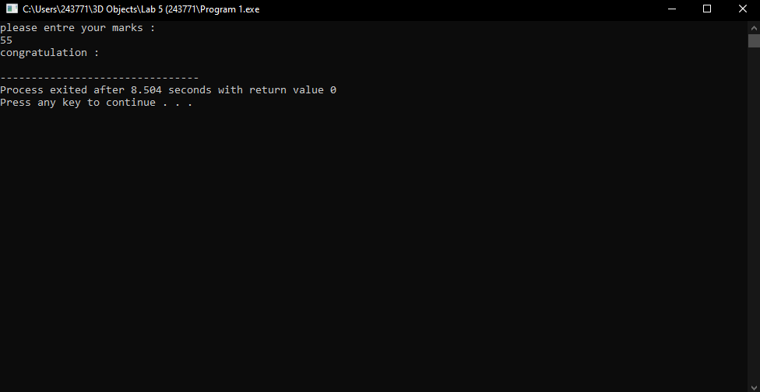

**TASK 2: (Description)**

**#include<iostream>**

**using namespace std;**

**int main()**

**{**

**int age;**

**cout<<"Please entre your age :"<<endl;**

**cin>>age;**

**if(age>18){**

**cout<<"You are Eligible to cast a vote :"<<endl;**

**}**

**return 0;**

**}**

**Screenshot:**

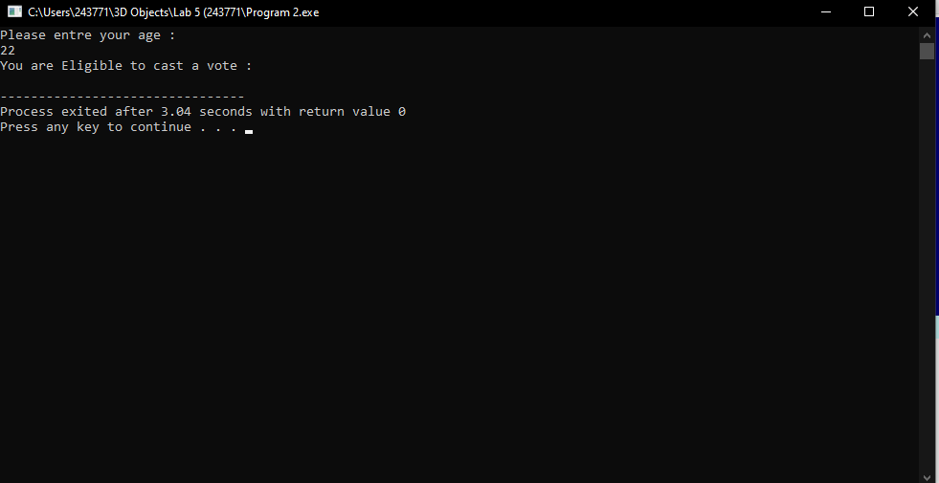

Task 3:

#include<iostream>

using namespace std;

int main()

{

int num;

cout<<"Please entre the number :"<<endl;

cin>>num;

if(num<0){

cout<<"The Number is negative :"<<endl;

}

else{

cout<<"The Number is positve :"<<endl;

}

return 0;

}

Screenshot:

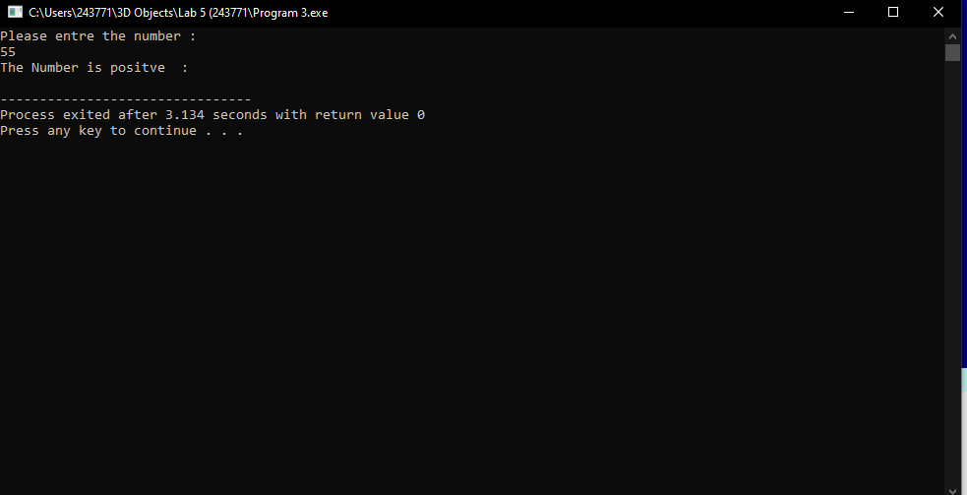Task 4:

#include<iostream>

using namespace std;

int main()

{

int num;

cout<<"Please entre your marks :"<<endl;

cin>>num;

if(num>90){

cout<<"Your Score is A :"<<endl;

}

else if(num>=80 && num>90){

cout<<"Your Score is B :"<<endl;

}

else if(num>=70 && num>79){

cout<<"Your Score is C :"<<endl;

}

else if(num<=60 && num<69){

cout<<"Your Score is D :"<<endl;

}

else{

cout<<"Your Score is F :"<<endl;

}

return 0;

}

Screenshot:

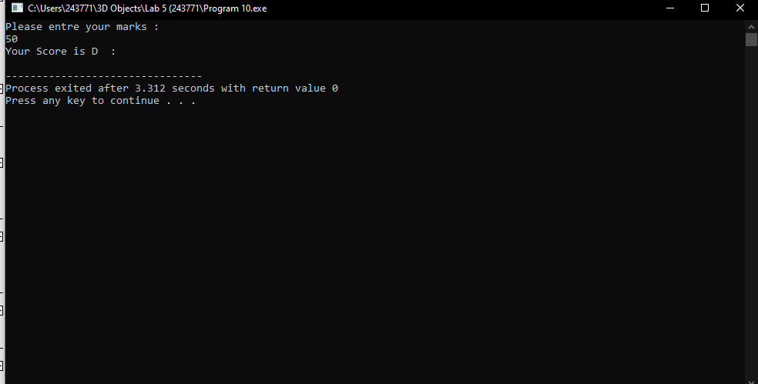Task 5:

#include<iostream>

using namespace std;

int main()

{

int Celsius;

cout<<"Please entre the temperature :"<<endl;

cin>>Celsius;

if(Celsius>0){

cout<<"It's above freezing :"<<endl;

}

else{

cout<<"It's freezing :"<<endl;

}

return 0;

}

Screenshot:

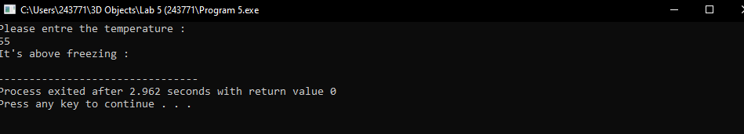Task 6:

#include<iostream>

using namespace std;

int main()

{

int num;

cout<<"Please entre your marks :"<<endl;

cin>>num;

if(num>90){

cout<<"Your Score is A :"<<endl;

}

else if(num>=80 && num>90){

cout<<"Your Score is B :"<<endl;

}

else if(num>=70 && num>79){

cout<<"Your Score is C :"<<endl;

}

else if(num<=60 && num<69){

cout<<"Your Score is D :"<<endl;

}

else{

cout<<"Your Score is F :"<<endl;

}

return 0;

}

Screenshot:

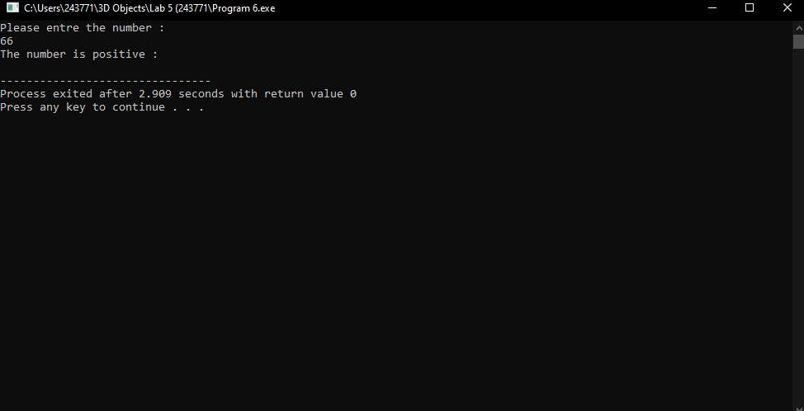Task 7:

#include<iostream>

using namespace std;

int main()

{

int num;

cout<<"Please entre your marks :"<<endl;

cin>>num;

if(num>75){

cout<<"Your Score is A :"<<endl;

}

else if(num>60){

cout<<"Your Score is B :"<<endl;

}

else if(num>45){

cout<<"Your Score is C :"<<endl;

}

else{

cout<<"Your Score is F :"<<endl;

}

return 0;

}

Screenshot:

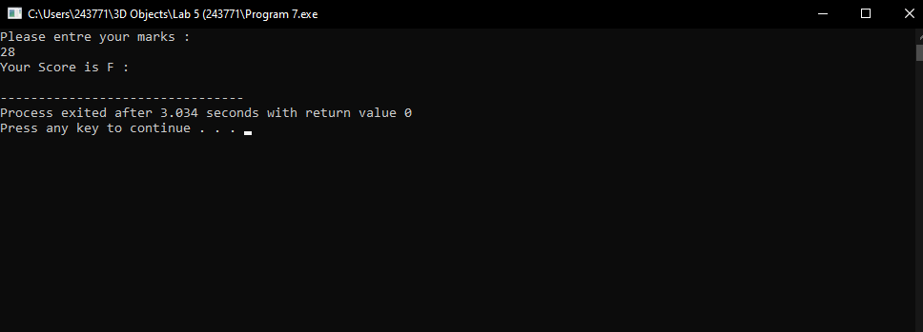Task 8:

#include<iostream>

using namespace std;

int main()

{

int num;

cout<<"Please entre the character :"<<endl;

cin>>num;

if(num=='a'){

cout<<"the characeter is vowel :"<<endl;

}

if(num=='e'){

cout<<"the characeter is vowel :"<<endl;

}

if(num=='i'){

cout<<"the characeter is is vowel :"<<endl;

}

if(num=='o'){

cout<<"the characeter is vowel :"<<endl;

}

if(num=='u'){

cout<<"the characeter is vowel :"<<endl;

}

else{

cout<<"the character is constant :"<<endl;

}

return 0;

}

Screenshot:

Task 9:

#include<iostream>

using namespace std;

int main()

{

double totalrate ,discountrate,discountamont,finalprice,totalpurchase;

cout<<"Please entre the total purchase amount :"<<endl;

cin>>totalpurchase;

if(totalpurchase<50){

cout<<"no discount :"<<endl;

}

if(totalpurchase<100){

cout<<"the discount is 10% :"<<endl;

}

if(totalpurchase<200){

cout<<"the discount is 15% :"<<endl;

}

if(totalpurchase>200){

cout<<"the discount is 20% :"<<endl;

}

else{

cout<<" :"<<endl;

}

return 0;

}

Screenshot :

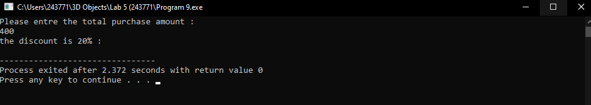Task 10;

#include<iostream>

using namespace std;

int main()

{

int num;

cout<<"Please entre your marks :"<<endl;

cin>>num;

if(num>90){

cout<<"Your Score is A :"<<endl;

}

else if(num>=80 && num>90){

cout<<"Your Score is B :"<<endl;

}

else if(num>=70 && num>79){

cout<<"Your Score is C :"<<endl;

}

else if(num<=60 && num<69){

cout<<"Your Score is D :"<<endl;

}

else{

cout<<"Your Score is F :"<<endl;

}

return 0;

}

Screenshot

